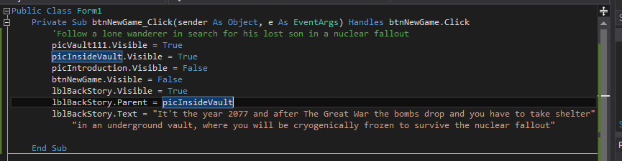

Chances are you will want your labels to be ON TOP of your picture boxes. For the text in the label to display properly, you need to use this command (circled in red above).

“picInsideVault” will be replaced with the name of the picturebox you want your label to be on top of!!!

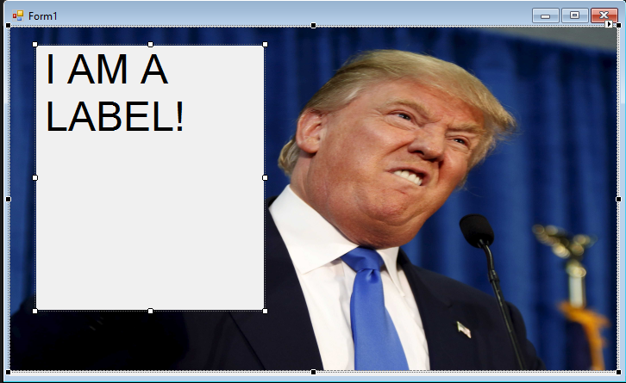

If you wish to make a label see through, you must modify the forecolor property. The picture to the right has a non transparent label.

Click forecolor. Go to “system” in the menu. Select “transparent”. The picture below shows what happens after these steps. When you run your program that label should be see through.

